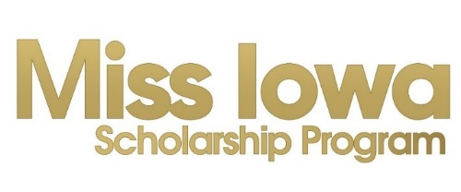

Miss Iowa New Local Preliminary Program License Proposal

  - Proposed Local Program Name:

Proposed Executive Director and Board Members (For person, please include name, anticipated Board role, age, employment, and competition experience, if any.)

Do you intend to hold an Open or Closed Program?

Open – Any candidate who resides, attends school, or works in the state of Iowa (as defined by criteria of Candidate Contract) is eligible to compete in the Local.

Closed – Any candidate who resides, attends school, or works in the specified geographic region of the local is eligible to compete. FYI – Most programs are open.

If Closed, please indicate the geographic region you intend to specify:

Teen Program
The Outstanding Teen Program is a fundraiser and sister program. Local and State programs are permitted to charge a reasonable fee for Teen candidates. Local Teen Fees range $150 - $200 per Teen candidate.
Note: No fee can be charged for Miss candidates by the Local Program. See MAO fees below.
What do you anticipate to charge as a fee for Teen candidates?

Potential Sponsors
List any ideas for potential sponsors for your program.
Gifts & Services ~

Monetary Donations/Scholarship Donors ~

Candidate Recruitment
Do you have ideas for recruiting Miss and Teen candidates? Please share:

Proposed Date & Venue
Potential Date:
Potential Venue:

Additional Comments or Notes: (Please share any additional ideas, comments, goals for your program.)

NOTE: All Candidates (Miss and Teen) are required to pay an annual $35 registration/membership fee to MAO for the local competition season (in Iowa, the local season is July to March). Miss candidates will also pay a $75 Local Registration fee through MAO for each local in which she competes. The local $75 fee is waived for Teen candidates.

